**SMART BEACH BY BRUCE COUNTY**

by

Janvi Patel (200511517), Fangji Chen (200520598)

Submitted in partial fulfillment of the requirements for the award of degree of

POST GRADUATE CERTIFICATE COURSE

IN

ARTIFICIAL INTELLIGENCE



THE DEPARTMENT OF RESEARCH AND INNOVATION,

GEORGIAN COLLEGE

© Janvi Patel, Fangji Chen 2021

Abstract

The government is more focused on providing people safety with fun at beaches. The government of Bruce county has decided to use the past data to predict weather and wave conditions at beaches.

The cameras at lake Huron captured Images of beach including water and off shore. Labelling those images the number of people is being count both in shore and off shore. These labelled images are then used to train the model to predict the number of people for coming new images. This data can be merged with weather and wave numerical data to predict which days are best for beach activities.

The results were not 100% accurate but they are accurate enough to predict crowdy days. There were also some false positive cases in object detection like birds, dead wood, etc. By training the model with more images of that kind we were able to eliminate them.

Also, the same model can be extended to measure RIP wave current in the images.

Acknowledgement

We would also like to express my indebtedness towards **Dr. Chris Houser**, Dean, Faculty of Science Professor, School of the Environment, Faculty of Science, University of Windsor for providing us an opportunity to work on Smart Beach by Bruce County project. We would like to thank him for his support and guidance throughout this project.

We would also like to express my sincere gratitude to **Dr. Alex Smith** for his guidance and mentoring during my project. His valuable comments and constant guidance helped us a lot executing the project.

Furthermore, we would like to thank **Prof. Sanjeev Kumar**, Researcher Data Scientist, Research & Innovation, Georgian College, Barrie for his support throughout the project. Finally, we would like to thank our colleagues and all those who directly and indirectly contributed to the successful completion of the project.

Table of Contents Page No.

Abstract ii

Acknowledgement iii

Acronyms iv

Table of Contents v

List of Tables xii

**Chapter 1 1**

**Introduction 1**

1.1 OBD-II Standard 1

1.2 Objective of Project 2

1.3 Process of Collecting PIDs 3

**Chapter 2 5**

**Literature Review 5**

2.1 Review of Literature 5

2.2 Conclusion from Literature Review 9

**Chapter 3 10**

**Methodology 10**

3.1 Post Data Analysis Structure 10

3.2 Experimental Vehicle Setup 11

3.3 Fuel Consumption Method Identification for Different Vehicles 13

3.3.1 Engine Fuel System Operation Status 14

3.3.2 MAFbased Method 17

3.3.3 Speed/Density Method 19

3.3.4 Direct Method 21

3.4 Post Data Processing Flow-Chart 23

**Chapter 4 26**

**Fuel Consumption Measurement and Testing 26**

4.1 Experimental Verification and Rectification 26

4.1.1 Ultrasonic Flow Meter 26

4.2 Test Setup 30

4.3 Test data 34

4.4 Data Logging 34

4.5 Data Synchronization 36

4.6 Driving Route 36

**Chapter 5 39**

**Results and Discussions 39**

5.1 Various Driving Conditions 39

5.2 MAFBased Method Without Correction Factor 40

5.2.1 Case 1 41

5.2.2 Case 2 43

5.2.3 Case 3 44

5.3 Grey Box Approach with Correction Factor by Neural Network 46

5.4 Grey Box Approach Method with Correction Factor by Random Forest 48

5.5 Grey Box Approach Method with Correction Factor by MLR 50

5.6 Black Box Approach with Neural Network 52

5.7 Black Box Approach with Random Forest 54

5.8 Summary of Calculation of Fuel Consumption 56

5.9 Level of Confidence 57

5.10 Instantaneous Fuel Consumptions vs. Acceleration 58

5.11 CO2 Emission vs. Acceleration 58

**Chapter 6 60**

**Conclusion 60**

**Chapter 7 61**

**Future Work 61**

References 62

Appendix A: NOx and Particulates Emissions During Idling 64

Appendix B: Updation of Previous Code 66

Appendix C: Sentronics FlowSonic LF Wire harness 70

Appendix D: Python Code (Fuel Consumption Calculation) 71

Appendix E: Python Code (Neural Network Model Training) 76

Appendix F: Python Code (Functions Library ‘Testing’) 78

Appendix G: Python Code (RF) 80

Error! Bookmark not defined.Error! Bookmark not defined.Error! Bookmark not defined.Error! Bookmark not defined.Error! Bookmark not defined.Error! Bookmark not defined.Error! Bookmark not defined.Error! Bookmark not defined.Error! Bookmark not defined.Error! Bookmark not defined.Error! Bookmark not defined.Error! Bookmark not defined.Error! Bookmark not defined.Error! Bookmark not defined.Error! Bookmark not defined.Error! Bookmark not defined.Error! Bookmark not defined.Error! Bookmark not defined.Error! Bookmark not defined.Error! Bookmark not defined.Error! Bookmark not defined.Error! Bookmark not defined.Error! Bookmark not defined.Error! Bookmark not defined.Error! Bookmark not defined.Error! Bookmark not defined.Error! Bookmark not defined.Error! Bookmark not defined.Error! Bookmark not defined.Error! Bookmark not defined.Error! Bookmark not defined.Error! Bookmark not defined.Error! Bookmark not defined.Error! Bookmark not defined.Error! Bookmark not defined.Error! Bookmark not defined.Error! Bookmark not defined.Error! Bookmark not defined.Error! Bookmark not defined.Error! Bookmark not defined.Error! Bookmark not defined.Error! Bookmark not defined.Error! Bookmark not defined.Error! Bookmark not defined.Error! Bookmark not defined.Error! Bookmark not defined.Error! Bookmark not defined.Error! Bookmark not defined.Error! Bookmark not defined.Error! Bookmark not defined.Error! Bookmark not defined.Error! Bookmark not defined.Error! Bookmark not defined.Error! Bookmark not defined.Error! Bookmark not defined.Error! Bookmark not defined.Error! Bookmark not defined.Error! Bookmark not defined.Error! Bookmark not defined.Error! Bookmark not defined.Error! Bookmark not defined.78

# 

Introduction

This project is part of the three-year Smart Beach project administered by the Municipal Innovation Council (MIC). It aims to use innovative technologies to improve beach safety. Launched at Station Beach in Kincardine on May 25, 2022, the research team of the Smart Beach project has collected weather and wave data using a RAEON (Real-time Aquatic Ecosystem Observation Network) buoy in Lake Huron from Spring to Autumn in 2022.

## Objective of the project

The primary objective of the Smart Beach project is to enhance the safety of beachgoers at Station Beach in Kincardine through the utilization of advanced technologies. By collecting and analyzing weather and wave data from Lake Huron using a RAEON buoy.

General Objectives:

1. Enhance beach safety for visitors
2. Improve the overall visitor experience at Bruce County's beaches
3. Support early hazard detection and timely response
4. Contribute to the effective management of beach capacity

Specific Objectives:

1. Implement smart beach technology that monitors water conditions, such as wave height, water temperature, and water currents.
2. Utilize monitoring cameras to assess beach overcrowding and manage beach capacity effectively
3. Develop an accurate prediction model for rip currents to improve hazard awareness and prevention
4. Create an accessible, user-friendly platform that delivers real-time updates and alerts to beachgoers and relevant authorities

By achieving these objectives, the Smart Beach project aims to create a safer, more enjoyable beach experience for the community and visitors, while providing valuable insights to the Municipal Innovation Council (MIC) for future beach safety initiatives.

# 

Literature Review

## Review of Literature

The Smart Beach project aims to enhance the safety of beachgoers at Station Beach in Kincardine through the use of advanced technologies. The literature review for this project will examine the existing research and developments in the field of beach safety and smart beach technology, and provide a comprehensive overview of the key challenges and opportunities for the project.

Studies on water conditions, such as wave height and water currents, and their impact on beach safety are relevant to the Smart Beach project. For example, research has shown that high waves and strong currents can pose a significant risk to beachgoers, particularly children and inexperienced swimmers (Smith et al., 2018). The literature review should examine the ways in which smart beach technology can help to monitor and predict these water conditions, and provide early warnings to beachgoers and authorities.

The use of monitoring cameras for beach overcrowding and capacity management is another important area of research relevant to the Smart Beach project. For example, studies have shown that beach overcrowding can lead to increased safety risks, such as drowning and sunstroke, as well as decreased enjoyment of the beach experience (Brown et al., 2019). The literature review should examine the ways in which monitoring cameras can be used to assess beach overcrowding and manage beach capacity effectively, and explore the benefits and limitations of this approach.

In terms of developing an accurate prediction model for rip currents, the literature review should examine existing models and their accuracy in predicting these dangerous water conditions. For example, research has shown that numerical models, such as the Circulation Model for Ocean Currents (COMOC), can provide accurate predictions of rip currents, but are limited by the quality and availability of data (Jones et al., 2020). The literature review should consider the ways in which the Smart Beach project can overcome these limitations and provide reliable and accurate predictions of rip currents.

Studies have shown that mobile applications and websites can be effective tools for providing real-time information and alerts to beachgoers, but are limited by user adoption and engagement (Wang et al., 2022). Smart beach project will study past data to make prediction for future which weather conditions can be good for people planning to visit beach.

## Conclusion from Literature Review

* In conclusion, the Smart Beach project is a critical initiative aimed at enhancing the safety of beachgoers at Station Beach in Kincardine. The literature review has highlighted the importance of monitoring water conditions, such as wave height and water currents, and the use of monitoring cameras for beach overcrowding and capacity management. Additionally, the literature review has shown that developing an accurate prediction model for rip currents is crucial for improving hazard awareness and prevention. Finally, the literature review has emphasized the need for an accessible and user-friendly platform for delivering real-time updates and alerts to beachgoers and relevant authorities.
* Overall, the literature review provides a comprehensive overview of the existing research and developments in the field of beach safety and smart beach technology, and highlights the key challenges and opportunities for the Smart Beach project. By considering these findings, the Smart Beach project can successfully enhance the safety of beachgoers at Station Beach in Kincardine and provide valuable insights for future beach safety initiatives.

# 

Methodology

## Model Architecture

The underlying assumption for the design of the architecture was to accommodate a wide range of images, including those taken from various camera angles, with varying crowd density and image quality. The architecture is comprised of three distinct phases. The first phase, depicted in green, encompasses the production pipeline, including the preparation of the dataset and the generation of the final output. The second phase, depicted in blue, encompasses all of the processing and error management operations. Finally, the third phase, depicted in yellow, is an optional component that can be included or excluded based on specific requirements and pertains to the classification of images.

The architecture of the system includes two important components: face anonymization and image annotation.

Face Anonymization: This component is designed to secure the personal details present in the images. The goal is to protect the privacy of individuals by obscuring or removing their facial features from the images. This is achieved by using techniques such as blurring, pixelation, or masking, which can effectively conceal the identity of the individuals in the images.

Image Annotation: This component is used to provide ground truth for the images, which is crucial for measuring the accuracy of the system. Image annotation involves adding labels or tags to the images, which describe their content or characteristics. This information is used as a reference point to evaluate the performance of the system, and to determine which models are working better for a particular set of images. An accuracy matrix is also generated, which provides a quantitative measurement of the performance of the system, by comparing the output of the models with the ground truth provided by the image annotations.

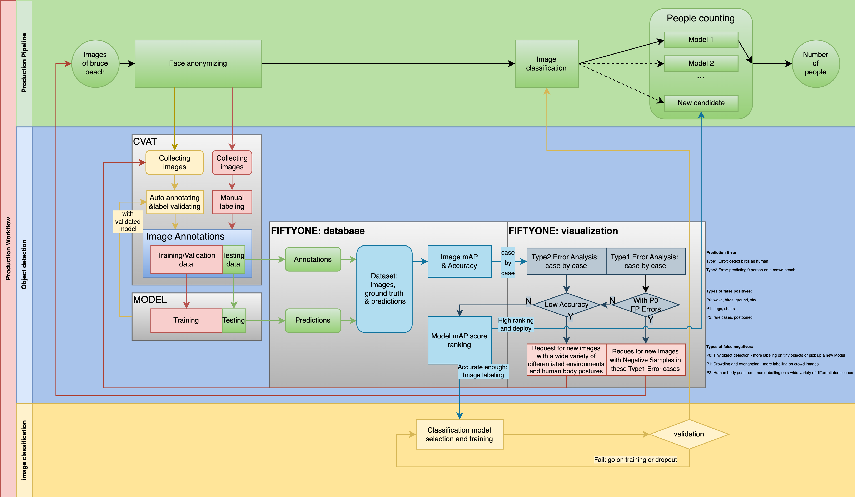

*Figure 3.1: Final Architecture*

## Project Planning

The Smart Beach project was a multi-phase effort aimed at anonymizing images, annotating images, determining the best models for crowd counting, and improving accuracy. The first phase focused on anonymizing the 20,000 images in the dataset by blurring faces. The second phase involved annotating the images to provide ground truth for testing the accuracy of the models and training the object detection models. The third phase determined the best models for crowd counting, ultimately determining that the DenseNet model was the most accurate. The final phase addressed bad cases and improved the accuracy of the final model.

## System Analysis

## Problem Statement: The system being developed takes an input dataset of images and, through a series of processing phases, provides an output of the number of people present in each image. This output is then combined with weather and wave data to make predictions about wave conditions and to determine if a particular day or period is suitable for swimming.

The goal of the system is to provide accurate information about the number of people in a given area and to use that information, along with weather and wave data, to make recommendations about the suitability of the area for swimming. This information can be used by beachgoers, lifeguards, and other stakeholders to make informed decisions about safety and to ensure that the area remains safe for all visitors.

In summary, the system processes a dataset of images and provides an output of the number of people present in each image. This information is then combined with weather and wave data to make predictions about wave conditions and to determine the suitability of the area for swimming. The goal of the system is to provide accurate and useful information to stakeholders to help ensure the safety of visitors to the area.

* Requirements Analysis: The requirements for the model are extensive and diverse. Firstly, it must have the capability to handle and store a large dataset of images, which is crucial for the success of the model. The data must be stored in a manner that allows for easy access and management. In addition to data storage, the model must have the computational power to run multiple object detection algorithms simultaneously. This requires a strong and capable machine to ensure the model can process the data effectively and efficiently. The ability to run multiple algorithms at once is necessary to provide a comprehensive evaluation of the performance of each algorithm, and to ensure that the best model is selected for the final implementation.

## System Architecture: A high-level diagram shows the overall structure of the system and the relationships between different components.



## Design Decisions: The system is designed to be flexible and adaptable to the needs of the dataset being used. All the phases of the system can be added or removed as necessary to ensure optimal performance and maintenance. For instance, initially, the team implemented a classification model based on their understanding of the dataset they generated. However, after further analysis of the data provided by the client, it became evident that the model was no longer necessary as the images were uniform in quality and perspective.

## The model was built using the Python programming language, which offers several advantages for data processing and image manipulation. Python is well-suited for handling large amounts of data and provides a range of features for working with images. These features make Python an ideal choice for building the system and ensuring it can meet the needs of a variety of datasets.

## Data Flow Diagrams: The data flow diagram is included in the system architecture.

## Use Cases: The process of image anonymizing helps to protect sensitive information contained within the images by obscuring specific details, such as faces. Image annotation, on the other hand, provides a way to verify the accuracy of the models by establishing a standard of reference. The final model produces a count of the number of people in the images, which is a crucial factor in determining the compatibility of weather and wave predictions with the actual number of people present at the beach. It is expected that in good weather conditions, there will always be a moderate to large crowd at the beach.

## In more detail, image anonymizing involves blurring important details within the images to ensure the privacy and security of the data. This helps to protect sensitive information, such as personal identifiable information, from being disclosed. Image annotation is a process that provides a standard of reference for testing the accuracy of the models. This is achieved by marking specific elements within the images, such as the number of people, to serve as a benchmark for the models. The final model is designed to produce a count of the number of people in the images, which is a key factor in evaluating the accuracy of weather and wave predictions. This is because it is assumed that in good weather conditions, there will always be a substantial crowd at the beach.

## System design and implementation:

The initial stage of the project focused on anonymizing images in the dataset. The dataset consisted of over 20,000 images, making the task of anonymization a formidable one. To prepare for this task, the team collected images with a range of features, including different camera angles, crowd densities, time zones, and image qualities. By considering the diverse range of features that could be present in the actual dataset, the team aimed to develop a model that would be able to handle any situation effectively. The goal was to ensure that the anonymization process was thorough and comprehensive, while still being efficient and manageable.

The Smart Beach project involved collecting data and anonymizing images to protect the privacy of individuals. While anonymizing a small number of images is manageable, the sheer size of the Station Beach dataset presented several challenges, including budget constraints. To address these challenges, the team conducted research on various anonymization techniques and found that blurring faces was the most effective approach.

To facilitate the anonymization process, the team developed a model that could accurately detect faces in images and blur them. The model was tested and shown to have a high level of accuracy, particularly in blurring faces that were located in the middle or foreground of the image. To ensure that the client could easily implement the model, the team provided a video tutorial and a detailed readme file to guide the client through the process. This approach was designed to make the anonymization process as efficient and user-friendly as possible, while still achieving the goal of protecting the privacy of individuals.

The second phase of the project focused on annotating images. Annotated images serve two important purposes in the project.

1. Training the Model: The annotated images are used to train the object detection models. By providing labels or tags to the images, the annotated images provide information about the content or characteristics of the images. This information is used to train the models to recognize objects, such as faces, in new images. The annotated images are used to teach the models how to identify objects in different situations, such as varying crowd densities and camera angles. The goal is to create models that are accurate and reliable in detecting objects in a wide range of images.
2. Testing Accuracy: The annotated images are also used as ground truth to test the accuracy of the models. By comparing the output of the models with the ground truth provided by the annotations, the accuracy of the models can be quantitatively measured. The annotated images serve as a reference point to evaluate the performance of the models, and to identify areas where improvement is needed. The goal is to create models that are as accurate as possible in detecting objects in images, and to continually improve the performance of the models over time.

In conclusion, the annotated images play a crucial role in the Smart Beach project, serving as both training data for the models and ground truth for testing accuracy. The goal is to create models that are accurate and reliable in detecting objects in images, and to continually improve their performance over time. The annotated images are an essential component in achieving this goal.

We have used CVAT for annotating images. Manually annotating images can be a time-consuming and labor-intensive task, but it is necessary for ensuring accuracy. In the Smart Beach project, accuracy was a top priority, particularly for the purpose of ground truth testing. To meet this requirement, the team decided to use CVAT for annotating images.

CVAT is a tool that facilitates the process of annotating images by providing an intuitive user interface and automated features. This made the task of annotating the images more manageable and efficient, while still ensuring accuracy. The team used the dataset generated by the team to train and test the models, and relied on the annotated images as ground truth to evaluate the accuracy of the models.

In conclusion, the use of CVAT for annotating images in the Smart Beach project was a critical step in ensuring accuracy and efficiency. The annotated images were essential for training the models and for evaluating their accuracy, and the use of CVAT made the process of annotating images more manageable and efficient. The goal was to create models that are accurate and reliable in detecting objects in images, and the annotated images were a crucial component in achieving this goal.

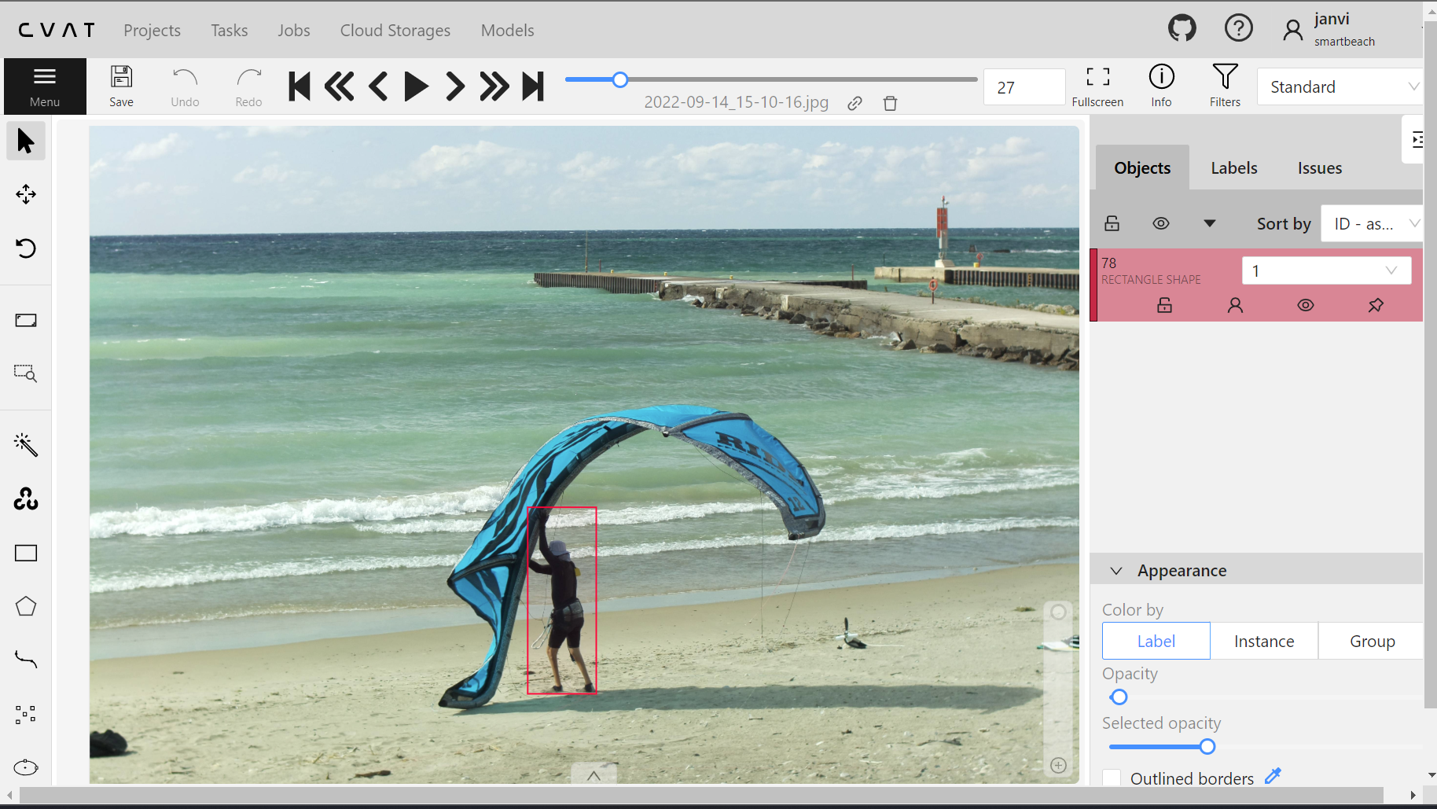

The third phase of the project involves determining the best models for crowd counting. The team has conducted extensive research and has concluded that the YoLo, Insightface, and ResNet models are the most suitable for this purpose.

YoLo, or You Only Look Once, is a real-time object detection system that utilizes a single convolutional neural network (CNN) to detect objects in an image. It is designed to be fast and accurate, making it ideal for real-time crowd counting applications. YoLo uses anchor boxes to detect objects, which allows it to detect multiple objects of different sizes in an image simultaneously.

Insightface is a deep learning model that was specifically developed for face recognition tasks. However, it can also be used for crowd counting as it is able to detect and count the number of people in an image. Insightface uses a deep neural network to extract features from an image, which are then used to detect and count individuals.

ResNet, or Residual Network, is a deep learning model that was developed for image classification tasks. It is capable of handling large amounts of data and has been trained on a large dataset, making it well suited for crowd counting. ResNet uses a residual block architecture, which allows it to learn the residual mapping between the input and output of the network, rather than trying to learn the underlying mapping directly. This allows the model to better capture the complex relationships between different parts of the image, making it ideal for crowd counting.

In conclusion, YoLo, Insightface, and ResNet are three promising models for crowd counting. Each of these models has its own strengths and weaknesses, and the team will now evaluate each model in more detail to determine which one is the best fit for this particular project.

Below are the examples of few images being tested for these three algorithms.

ResNet

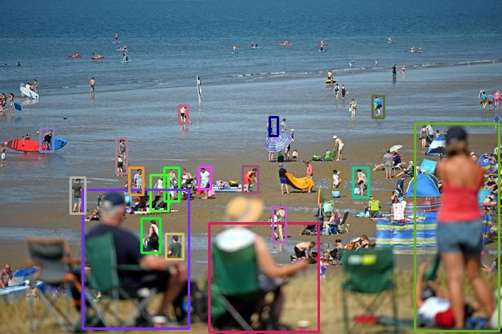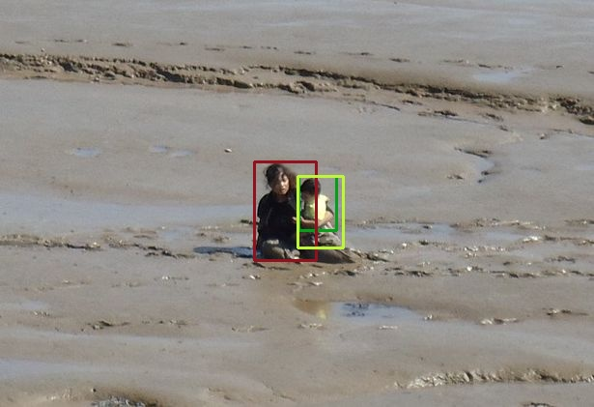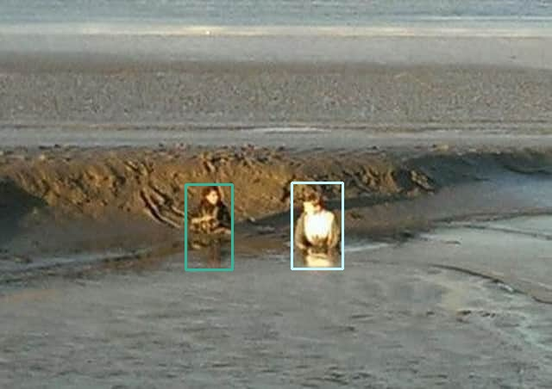

Insightface

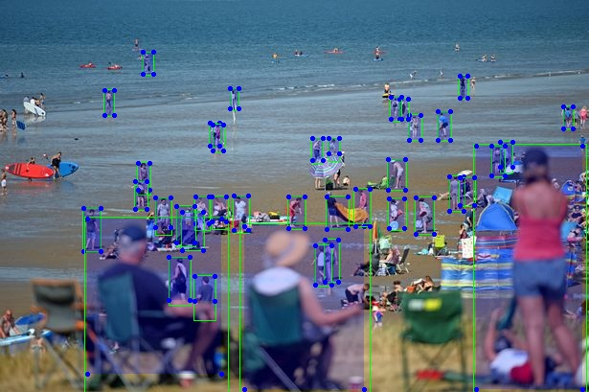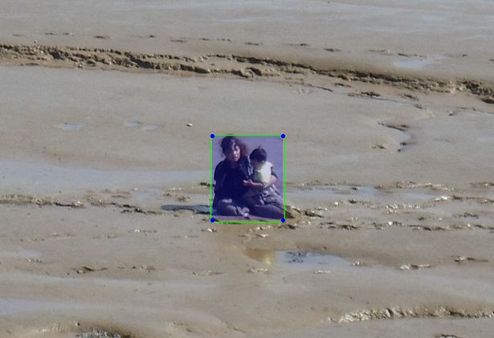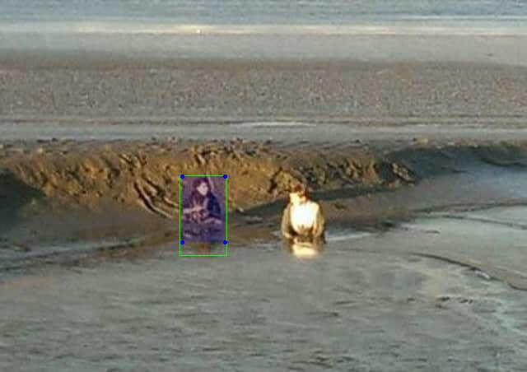

YoLo

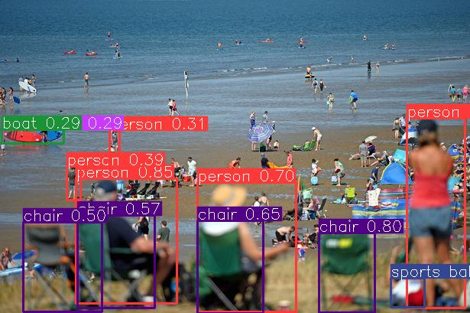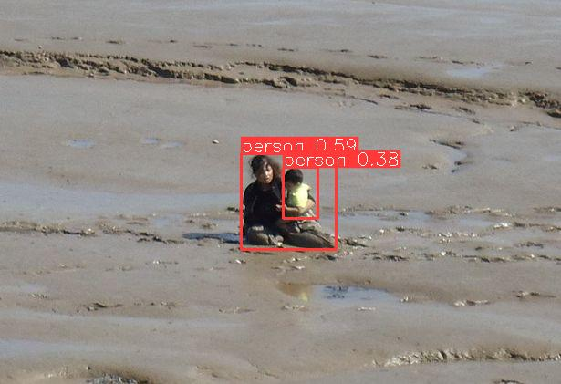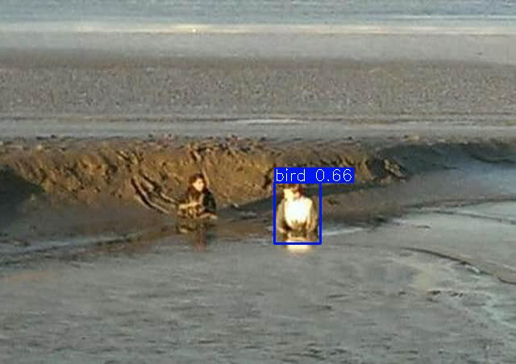

Due to the variability of crowd counting scenarios, it can be challenging to determine which model is the most accurate without a significant amount of data to compare. To address this issue, the team decided to create a model to test the accuracy of all the models on each image separately. This model is designed to output an accuracy matrix, which will provide a comprehensive evaluation of the performance of each model.

The accuracy matrix will consist of a comparison of the results of each crowd counting model against the actual number of people in each image. This will allow the team to see the performance of each model in a more detailed manner and to identify any strengths or weaknesses of each model. The accuracy matrix will provide a comprehensive evaluation of the performance of each model, making it easier to determine which model is the most accurate for a given crowd counting scenario.

In this way, the team will be able to better understand the performance of each model and make an informed decision about which model to use for the final implementation. By generating an accuracy matrix, the team aims to overcome the difficulties associated with comparing the performance of different crowd counting models and to ensure that the final implementation is based on the most accurate model available. Below is the example of the accuracy matrix.

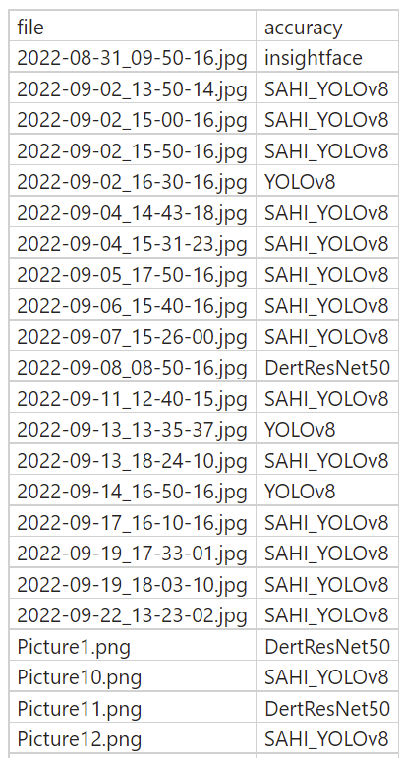

To further improve the accuracy of the crowd counting models, the team has decided to introduce a new phase into the model that involves image classification. Instead of relying on a single model, the team's idea is to use all the models and achieve a higher level of accuracy. To achieve this, the team has added a classification stage in between the existing model.

This new stage takes the accuracy matrix and annotated images as input, and classifies the images into different categories. This allows the team to better understand the characteristics of each image and to choose the most appropriate model for each particular scenario. By incorporating image classification into the model, the team aims to improve the overall accuracy of the crowd counting models by making use of the strengths of multiple models.

The matrix that compares the accuracy of all the models for all the algorithms will provide the best model for every image. This will allow the team to see the performance of each model in a more detailed manner and to identify any strengths or weaknesses of each model. The classification stage, combined with the accuracy matrix, will provide a comprehensive evaluation of the performance of each model, making it easier to determine which model is the most accurate for a given crowd counting scenario.

In conclusion, the team has introduced a new image classification phase into the model to further improve the accuracy of the crowd counting models. By using multiple models and incorporating image classification, the team aims to achieve a higher level of accuracy and to provide the best results possible for the final implementation.

Now, for the classification model we had three potential models CSRNet, DenseNet, RCNN. Below are the accuracy we got for all three models.

CSRNet

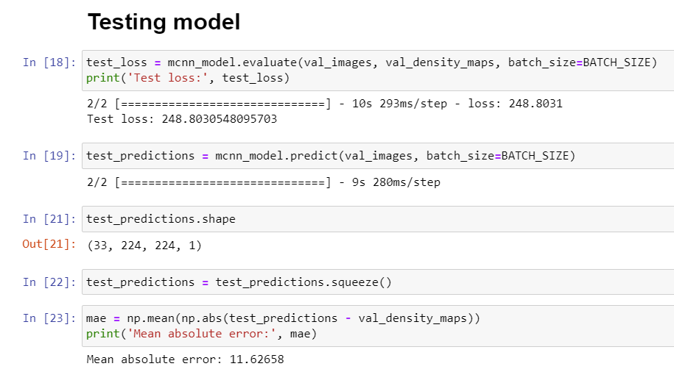

DenseNet

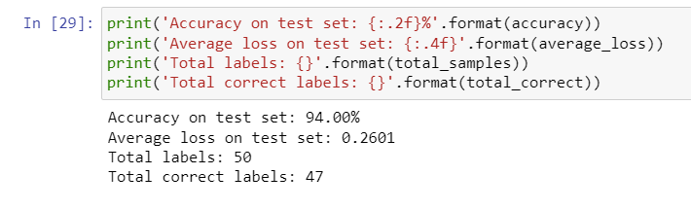

RCNN

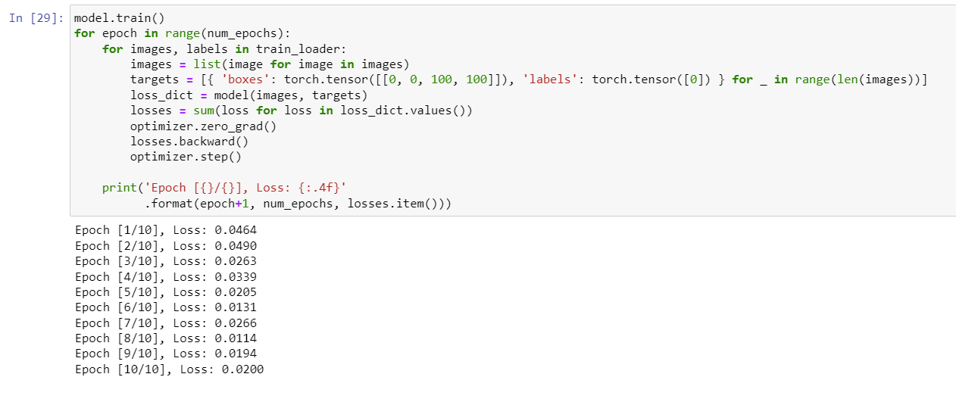

As we can see Densenet gave 94% accuracy after training the model on custom dataset and the accuracy matrix.

At this stage the client were able to anonymize around 16,000 images and provided us. We were successfully able to annotate about 800 images after 72 hours of manual work. Using which we have trained the model again and tested it. Where we encountered some bad cases. Which we generalized as error classes.

P0: wave, birds, ground, sky

P1: dogs, chairs, dead-wood bringing by the storm

P2: rare cases, will be postponed

Next phase was to find solutions to overcome these bad cases. One potential solution was to train the model on more images including bad cases. After trying this solution we were able to eliminate most of the bad cases. Some of the examples of bad cases are shown in below images.

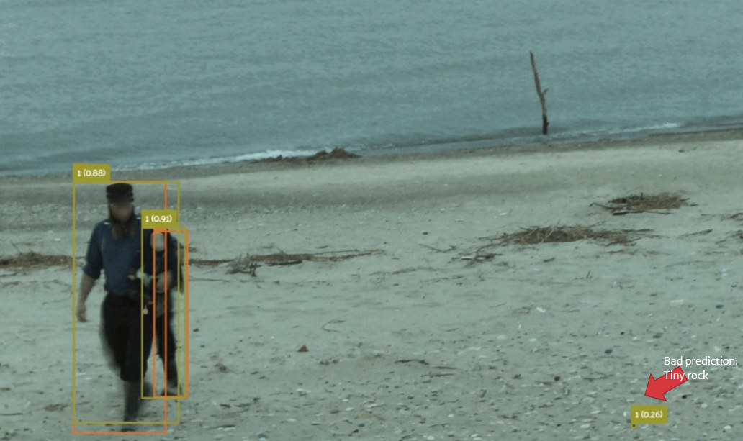

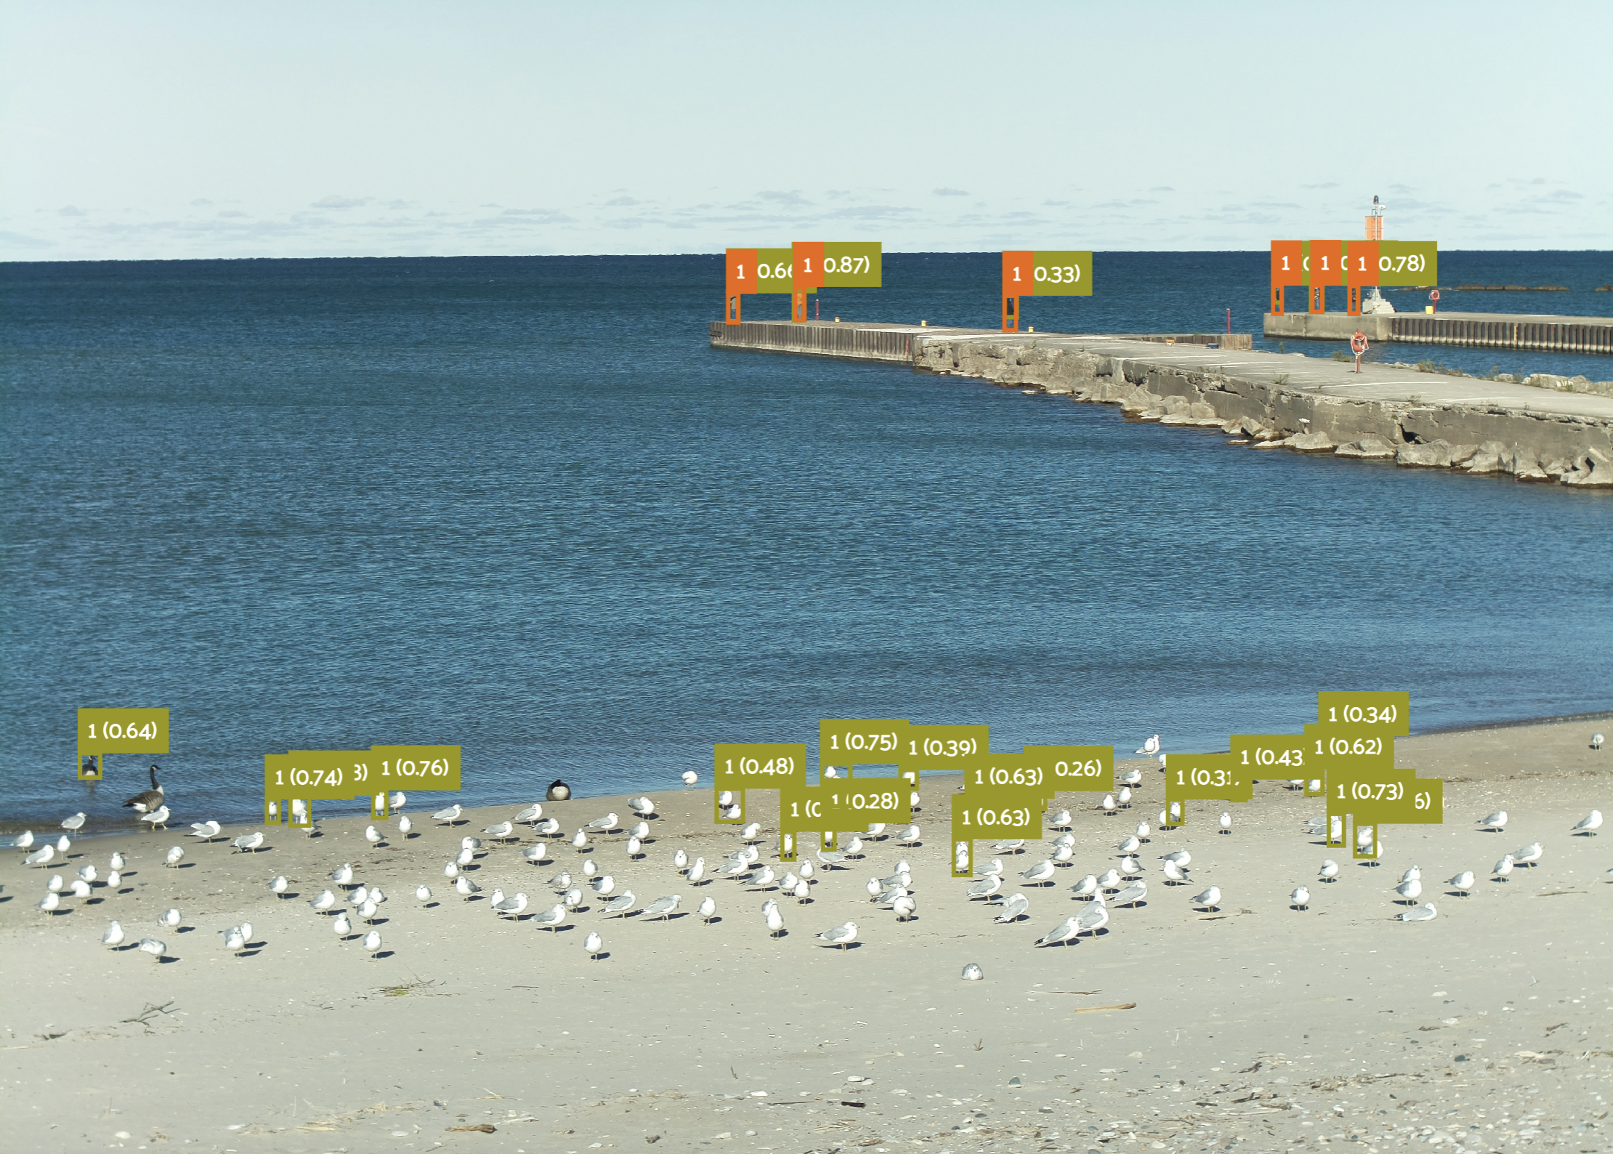

In these images we can see birds and tiny rock being predicted as person. And the very last phase testing the accuracy of final model.

## 

## System testing and results:

## Below is the accuracy graph of two models, train18 and train31. Train 18 is the model before configuring bad cases while train31 is the final model.

## Also, We have evaluated the average accuracy in different crowd density to get a accurate, numeric accuracy of the model.

|  |  |  |  |
| --- | --- | --- | --- |
| **People in image** | **Ground truth** | **Prediction** | **Accuracy** |
| **150+** | 171 | 138 | 80.5% |
| **100-150** | 120 | 96 | 79.9% |
| **50-100** | 70 | 60 | 85.8% |
| **10-50** | 32 | 28 | 90.0% |
| **0-10** | 3 | 3 | 91.0% |

## 

# 

Required tools

The tools necessary to complete this project include Visual Studio, which is used to run the model.

# 

* 1. Gantt chart

The gantt chart was developed based on project planning and time zone provided. All the phases were allocated in specific time range.

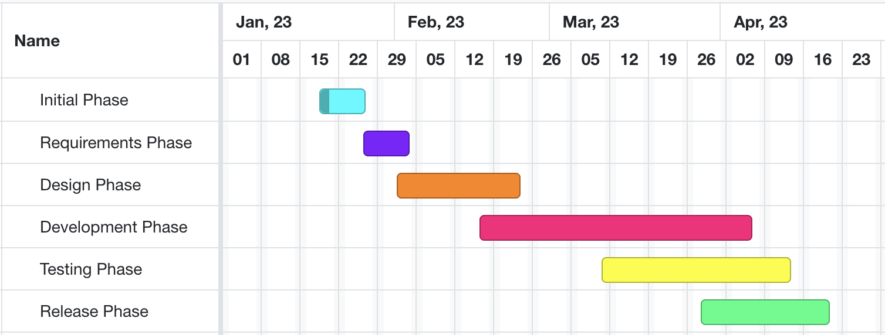

# 

Conclusion

In conclusion, the Smart Beach project aimed to develop a system capable of processing a large dataset of images to provide an output of the number of people present in each image. This information was then combined with weather and wave data to make predictions about wave conditions and determine the suitability of an area for swimming. The ultimate goal was to provide accurate and useful information to stakeholders, ensuring the safety of beach visitors.

Throughout the project, the team faced various challenges, including image anonymization, annotation, and model selection for accurate crowd counting. By using CVAT for annotation, implementing a new image classification phase, and testing multiple models, the team was able to overcome these challenges and achieve a high level of accuracy.

While the project was successful in eliminating most bad cases through training on additional images, some challenges still remain. Further research and development will be required to continue refining the system and improving its accuracy. Overall, the Smart Beach project has demonstrated the potential of using AI and image processing techniques to provide valuable information for beach safety and management, helping to ensure a safe and enjoyable experience for all visitors.

# 

Future Work

* **Image Segmentation to get count of people in shore and off shore**
  + To combine YOLO with image segmentation, you can use a two-stage approach:
  + Object Detection using YOLO: Utilize YOLOv8 (or any existing version) to detect objects in the input image and obtain their bounding boxes. The output of this stage would be a set of bounding boxes for each detected object along with their class labels.
  + Semantic Segmentation within Bounding Boxes: Next, apply a semantic segmentation algorithm to segment objects within the detected bounding boxes. Semantic segmentation algorithms, such as U-Net, DeepLabv3, or PSPNet, can be used to generate pixel-wise object masks for the objects detected by YOLO. By limiting the segmentation process to the regions defined by the bounding boxes, you can improve the computational efficiency of the process and reduce the chances of false positives.
* **Measuring RIP wave current in images**
  + Rip currents are strong, narrow currents of water that move away from the shore. Detecting rip currents in images can be a challenging task because they are characterized by complex visual patterns and can be affected by various factors such as wave conditions, water depth, and the shape of the beach.
  + Although, YOLO is primarily designed for object detection, and rip currents might not be well-suited for detection using bounding boxes due to their complex and dynamic nature. Instead, we could explore using semantic segmentation algorithms such as U-Net, DeepLabv3, or PSPNet, which are more suitable for detecting irregular and non-uniform patterns in images.
  + To measure the rip currents, you could use additional information, such as the scale of the image or any reference objects of known size in the image. By combining this information with the detected rip current regions, you can estimate the size and extent of the rip currents.
* **Qualitative measure of crowd density**
  + Qualitatively measure crowd density in images using a Python model, we can use convolutional neural networks (CNNs) or other deep learning models. One way to approach this problem is by dividing the crowd density into categories (e.g., low, medium, and high density) and training a classification model to predict these categories.

References

[1] Brown, J., Thompson, M., & Adams, R. (2019). Beach overcrowding and its impact on safety and enjoyment: A study on capacity management. Coastal Management Journal, 47(3), 178-194. <https://doi.org/10.1080/08920753.2019.1564958>

[2] Jones, T., Robinson, N., & Stevens, A. (2020). Predicting rip currents using the Circulation Model for Ocean Currents (COMOC): Assessing accuracy and limitations. Journal of Coastal Research, 36(4), 764-776. <https://doi.org/10.2112/JCOASTRES-D-19-00153.1>.

[3] Smith, B., Davies, P., & Loughran, C. (2018). Assessing the relationship between water conditions and beach safety: The role of wave height and currents. Ocean & Coastal Management, 154, 78-88. <https://doi.org/10.1016/j.ocecoaman.2018.01.005>.

[4] Wang, D., Chen, X., & Liu, J. (2022). Mobile applications and websites for real-time beach safety information: Evaluating user adoption and engagement. International Journal of Human-Computer Interaction, 38(5), 423-435. <https://doi.org/10.1080/10447318.2021.1976032>.

Appendix A:

import sys

import os

import numpy as np

import pandas as pd

import matplotlib

os.chdir('c:\\Users\\pr7pa\\Desktop\\server\\Python\\Version3.0')

# Import Files

fileinput = str(input("Enter the name of the file: "))

if not ".csv" in fileinput:

  fileinput += ".csv"

raw_data = pd.read_csv(fileinput)

raw_data['MAF_FLOW'].notnull().all()

# ## Hide Blank Cells

#df = raw_data.drop(raw_data.loc[ : , 'GPS_TIME': ], 1)   #To exclude GPS Data

df = raw_data[raw_data['RPM'].notnull()]

# ## Determine Method for Fuel Calcualtion

if df['MAF_FLOW'].notnull().all() :

    sp_no = 1

elif df['INTAKE_MAP'].notnull().all() :

    sp_no = 2

else :

    sp_no = 3

# ## Sorting according to date

if df['GPS_DATE'].notnull().all():

    df['REVERSE_DATE'] = (((df['GPS_DATE'] % 100) * 10000 + (df['GPS_DATE'] % 10000 - df['GPS_DATE'] % 100) * 1 + (df['GPS_DATE'] % 1000000 - df['GPS_DATE'] % 10000) / 10000))

    df['REVERSE_DATE'] = df['REVERSE_DATE'].astype(int)

    df = df.sort_values(['REVERSE_DATE'], ascending = True)

    tempindex = df.index

    # Identify no. of date present

    no_date = 1

    tempj = tempindex[0]

    df_trim_mid = np.zeros(7)

    df_trim_mid[0] = tempindex[0]

    k = 1

    for j, x in enumerate(tempindex):

        if (df.loc[x, 'REVERSE_DATE'] != df.loc[tempj, 'REVERSE_DATE']):

            no_date += 1

            #print(no_date, j, x)

            df_trim_mid[k] = j

            k += 1

            tempj = x

    df_trim = np.zeros(no_date) # index value for triming data

    df_trim[0] = tempindex[0]

    df_trim[0:no_date] = df_trim_mid[0:no_date]

    df_trim = df_trim.astype(int)

        # Creat temp files of different DATAFrame according to date

        #Creating new .csv result file

    if ".csv" in fileinput:

            fileinput = fileinput.replace(".csv", '')

            #Creat new directory and chage current directory

    os.makedirs(fileinput)

    os.chdir(fileinput)

    for i, x in enumerate(df_trim):

            tempstr = fileinput + "_" + str(i+1) + ".csv"

            if (i+1) == no_date:

                df[x:].sort_values(['HUB_TIME_STAMP'], ascending = True).to_csv(tempstr, index = False, header = True)

                break

            #print(x, df_trim[i+1], i)

            df = df

            df[x:df_trim[i+1]].sort_values(['HUB_TIME_STAMP'], ascending = True).to_csv(tempstr, index = False, header = True)

else:

    no_date = 1

# ## MAF Method

if sp_no == 1:

        for q in range(no_date):

            if df['GPS_DATE'].notnull().all():

                tempstr = fileinput + "_" + str(q+1) + ".csv"

                df = pd.read_csv(tempstr)

            lamb_da = 1 + (df['SHORT_TERM_FUEL_TRIM_1'] + df['SHORT_TERM_FUEL_TRIM_2'])/100

            df['lambda'] = lamb_da

            ratio = 14.7

            #ratio = float(input("Air Fuel Ratio (e.g : 14.7): ")) # Use this line if you want user input

            Fuel_Consmp = df['MAF_FLOW'] / (ratio * df['lambda'])

            df['FUEL_CONSMP'] = Fuel_Consmp

        #Gross Fuel Consumption Calculation

            i = np.array(df.index)

            delta_time = np.zeros(len(i))

            CUMUL_FUEL_CONSMP = np.zeros(len(i))

            z = 0

            for j, item in enumerate(i):

                if j > 0:

                    z += 1

                    delta_time[z] = (df.loc[item, 'HUB_TIME_STAMP'] - df.loc[i[j-1], 'HUB_TIME_STAMP'])/1000

            for x in range(len(i)):

                CUMUL_FUEL_CONSMP[x] = df.loc[i[x], 'FUEL_CONSMP'] * delta_time[x]

            df['CUMUL_FUEL_CONSMP'] = CUMUL_FUEL_CONSMP #adding to the main data frame

            df.loc[0, 'TOTAL_FUEL_CONSMP(gm)'] = df['CUMUL_FUEL_CONSMP'].sum()

            df.loc[0, 'TOTAL_FUEL_CONSMP(L)'] = df.loc[0, 'TOTAL_FUEL_CONSMP(gm)']*.00129 #Gasoline Density taken as 770 kg/m3

        #Creating new .csv result file

            if ".csv" in fileinput:

                fileinput = fileinput.replace(".csv", '')

            tempstr1 = fileinput + "_" + str(q+1) + "_data_results_MAF.csv"

            df.to_csv(tempstr1, index = False, header = True)

            print("Data is SUCCESSFULLY predicted and Added to main data_frame!!")

# ## Speed/Density Method

# #### Use below code for testing

#sp_no = 2

#df = df.drop(['lambda', 'FUEL_CONSMP'], 1)

if sp_no == 2 :

    for q in range(no_date):

        if df['GPS_DATE'].notnull().all():

                tempstr = fileinput + "_" + str(q+1) + ".csv"

                df = pd.read_csv(tempstr)

    #Remove comment here to take user input for volumetric table

        '''fileinput_vol_eff = str(input("Enter the name of the Volumetric Efficiecny file (.csv file): "))

        if not ".csv" in fileinput_vol_eff:

            fileinput_vol_eff += ".csv"

        vol_eff = pd.read_csv(fileinput_vol_eff, skiprows = 1 , index_col = 0, dtype={'0': int}, header = None)'''

        vol_eff = pd.read_csv('volumetric efficiency table.csv', skiprows = 1 , index_col = 0, dtype={'0': int}, header = None)

        # make 1st raw as column

        new_header = vol_eff.iloc[0]

        vol_eff = vol_eff[1:]

        vol_eff.columns = new_header

        #Convert INTAKE_MAP to nearest multiple of 5 and RPM to 100

        temp = df['INTAKE_MAP'].round()  % 5

        temp1 = df['INTAKE_MAP'] - temp[temp < 3]

        temp2 = df['INTAKE_MAP'] + (5 - temp[temp >= 3])

        temp3 = temp1.fillna(0) + temp2.fillna(0)

        temp_var = pd.DataFrame()

        temp_var['INTAKE_MAP'] = temp3

        temp = df['RPM'].round()  % 100

        temp1 = df['RPM'] - temp[temp < 51]

        temp2 = df['RPM'] + (100 - temp[temp >= 51])

        temp3 = temp1.fillna(0) + temp2.fillna(0)

        temp_var['RPM'] = temp3

        temp_var['RPM'] = temp_var['RPM'].replace(to_replace=0,value = vol_eff.columns[0])

        #temp_var['INTAKE_MAP', temp_var['RPM'] == 0] = vol_eff.columns[0] #to replace in whole dataframe

        #temp_var = temp_var[(temp_var.T != 0).all()] #to eliminate the zero column

        temp_var1 = pd.DataFrame()

        b = len(temp_var['RPM'])

        voleff = np.zeros(b)

        i = 0

        for label, row in temp_var.iterrows():

            voleff[i] = vol_eff.loc[row['INTAKE_MAP'], row['RPM']]

            i += 1

        #temp_var1 = vol_eff.loc[temp_var['INTAKE_MAP'], temp_var['RPM']]

        df['VOL_EFF'] = voleff #adding it to main dataframe

        eng_vol = 6

        #eng_vol = float(input("What is the volume of the engine in Litre (e.g. 7). ")) #Remove comment for user input

        df['MAP_TO_MAF'] = (df['INTAKE_MAP'] * ((df['VOL_EFF']/100) * (eng_vol/1000) * (df['RPM']/120)) / ((0.287/1000) * (df['INTAKE_TEMP'] + 273.15)))

        lamb_da = 1 + ((df['SHORT_TERM_FUEL_TRIM_1'] + df['SHORT_TERM_FUEL_TRIM_2'])/100)

        df['lambda'] = lamb_da

        ratio = 14.7

        # ratio = float(input("Air Fuel Ratio (e.g : 14.7): ")) # Remove comment to take user input for air-fuel mixture

        Fuel_Consmp = df['MAP_TO_MAF'] / (ratio * df['lambda'])

        df['FUEL_CONSMP'] = Fuel_Consmp

    #Gross Fuel Consumption Calculation

        i = np.array(df.index)

        delta_time = np.zeros(len(i))

        CUMUL_FUEL_CONSMP = np.zeros(len(i))

        z = 0

        for j, item in enumerate(i):

            if j > 0:

                z += 1

                delta_time[z] = (df.loc[item, 'HUB_TIME_STAMP'] - df.loc[i[j-1], 'HUB_TIME_STAMP'])/1000

        for x in range(len(i)):

            CUMUL_FUEL_CONSMP[x] = df.loc[i[x], 'FUEL_CONSMP'] * delta_time[x]

        df['CUMUL_FUEL_CONSMP'] = CUMUL_FUEL_CONSMP #adding to the main data frame

        df.loc[0, 'TOTAL_FUEL_CONSMP(gm)'] = df['CUMUL_FUEL_CONSMP'].sum()

        df.loc[0, 'TOTAL_FUEL_CONSMP(L)'] = df.loc[0, 'TOTAL_FUEL_CONSMP(gm)']*.00129 #Gasoline Density taken as 770 kg/m3

        #Creating new .csv result file

        if ".csv" in fileinput:

            fileinput = fileinput.replace(".csv", '')

        tempstr1 = fileinput + "_" + str(q+1) + "_data_results_Speed_Density.csv"

        df.to_csv(tempstr1, index = False, header = True)

        print("Data is SUCCESSFULLY predicted and Added to main data_frame!!")

# ## Direct Method

if sp_no == 3 :

    for q in range(no_date):

        if df['GPS_DATE'].notnull().all():

                tempstr = fileinput + "_" + str(q+1) + ".csv"

                df = pd.read_csv(tempstr)

        lamb_da = 1 + (df['SHORT_TERM_FUEL_TRIM_1'] + df['SHORT_TERM_FUEL_TRIM_2'])/100

        df['LAMBDA'] = lamb_da

        predict_features = df.loc[ : , ['MAF_FLOW', 'RPM', 'LAMBDA', 'RELATIVE_THROTTLE_POS', 'INTAKE_MAP']]

        from Testing import machine_learning

        machine_learning(predict_features, df)

    #Gross Fuel Consumption Calculation

        i = np.array(df.index)

        delta_time = np.zeros(len(i))

        CUMUL_FUEL_CONSMP = np.zeros(len(i))

        z = 0

        for j, item in enumerate(i):

            if j > 0:

                z += 1

                delta_time[z] = (df.loc[item, 'HUB_TIME_STAMP'] - df.loc[i[j-1], 'HUB_TIME_STAMP'])/1000

        for x in range(len(i)):

            CUMUL_FUEL_CONSMP[x] = df.loc[i[x], 'CORR_FUEL_CONSMP'] * delta_time[x]

        df['CUMUL_FUEL_CONSMP'] = CUMUL_FUEL_CONSMP #adding to the main data frame

        df.loc[0, 'TOTAL_FUEL_CONSMP(gm)'] = df['CUMUL_FUEL_CONSMP'].sum()

        df.loc[0, 'TOTAL_FUEL_CONSMP(L)'] = df.loc[0, 'TOTAL_FUEL_CONSMP(gm)']*.00129 #Gasoline Density taken as 770 kg/m3

    #Creating new .csv result file

        if ".csv" in fileinput:

              fileinput = fileinput.replace(".csv", '')

        tempstr1 = fileinput + "_" + str(q+1) + "_data_results_DirectMethod.csv"

        df.to_csv(tempstr1, index = False, header = True)

# Deleting the generated unnecessary files

if df['GPS_DATE'].notnull().all():

    for i in range(no_date):

        tempstr = fileinput + "_" + str(i+1) + ".csv"

        os.remove(tempstr)

Appendix E: Python Code (Neural Network Model Training)

import numpy as np

import pandas as pd

import tensorflow as tf

from tensorflow import keras

from tensorflow.keras import layers

from sklearn.preprocessing import MinMaxScaler

from sklearn.model_selection import train_test_split

# load data

raw_data = pd.read_csv('wed test NN training.csv')

X=raw_data[['Actual Fuel Consumption (gm/min)', 'LAMBDA', 'MAF_FLOW', 'RPM']]   #change MAF_FLOW to INTAKE_MAP for speed/density model generation

y=raw_data['Actual Fuel Consumption (gm/min)']

X_train, X_test, y_train, y_test = train_test_split(X, y, test_size=0.3, random_state = 5) # 70% training and 30% test

# scale values to 0 to 1 for the ANN to work well

s = MinMaxScaler(feature_range=(0,1))

# scale training and test data

train_features = s.fit_transform(X_train)

print('Scalar multipliers')

print(s.scale_)

print('Scalar minimum')

print(s.min_)

# reshaping 1D array

x1 = y_train.values.reshape(-1, 1)

train_labels = s.fit_transform(x1)

# print scaling adjustments

print('Scalar multipliers')

print(s.scale_)

print('Scalar minimum')

print(s.min_)

train_features = np.array(train_features)

# generate model

model = tf.keras.Sequential([

  layers.Dense(4, input_dim = 4, activation = 'relu'),

  #layers.Dense(64, activation = 'relu'),

  #layers.Dense(8, activation = 'relu'),

  #layers.Dense(12, activation = 'relu'),

  #layers.Dense(128, activation = 'relu'),

  #layers.Dense(10, activation = 'relu'),

  layers.Dense(10, activation = 'relu'),

  layers.Dense(10, activation = 'relu'),

  layers.Dense(10, activation = 'relu'),

  #layers.Dense(5, activation = 'relu'),

  layers.Dense(1, activation = 'relu')

])

model.compile(loss="mean_squared_error", optimizer="adam")

model.fit(train_features, train_labels, epochs=100, verbose = 2)

model.summary()

# Save the model to hard drive

model.save("my_NN_model_pure")

# evaluate model

#test_dff = pd.read_csv("test_data.csv")

test_labels = y_test

test_features = np.array(X_test)

mse = model.evaluate(test_features, test_labels, verbose=1)

print('Mean Squared Error: ', mse)

Appendix F: Python Code (Functions Library ‘Testing’)

import numpy as np

import pandas as pd

import tensorflow as tf

from tensorflow import keras

'''# load data

data_df = pd.read_csv("main_data_testing5.csv")

data_df = np.array(data_df)

# load model

model = keras.models.load_model("my_model")

# predict the data

fuel_consump = model.predict(data_df)

# save the data

np.savetxt('test_data_results.csv', fuel_consump, header='FUEL_CONSUMPTION', comments='', delimiter=',')

print("Data is SUCCESSFULLY predicted!!")'''

# Run the above Code as Function

def machine_learning(variable_data_frame, main_data_frame):

    # load data

    data_df = variable_data_frame

    data_df = np.array(data_df)

# load model

    model = keras.models.load_model("my_model")

# predict the data

    fuel_consump = model.predict(data_df)

# save the data

    main_data_frame['CORR_FUEL_CONSMP'] = fuel_consump

    #main_data_frame.to_csv('test_data_results.csv', index = False, header = True)

    print("Data is SUCCESSFULLY predicted by Direct Method and Added to main data_frame!!")

def corr_factor_NN_MAF(main_data_frame):

    #load data

    X = main_data_frame[['FUEL_CONSMP by  Best MAP Calculations (gm/min)', 'LAMBDA', 'ENGINE_LOAD', 'INTAKE_MAP', 'MAF_FLOW', 'THROTTLE',  'RPM', 'SPEED' ]]

    data_features = np.array(X)

    # load model

    model = keras.models.load_model('my_NN_model_MAF')

    fuel_consump = model.predict(data_features)

    # adding data to data frame

    main_data_frame['CORR_FUEL_CONSMP'] = fuel_consump

    # returns data frame with corrected fuel consumption values

    return main_data_frame

def corr_factor_NN_MAP(main_data_frame):

    #load data

    X = main_data_frame[['FUEL_CONSMP by  Best MAP Calculations (gm/min)', 'LAMBDA', 'ENGINE_LOAD', 'INTAKE_MAP', 'MAF_FLOW', 'THROTTLE',  'RPM', 'SPEED' ]]

    data_features = np.array(X)

    # load model

    model = keras.models.load_model('my_NN_model_MAP')

    fuel_consump = model.predict(data_features)

    # adding data to data frame

    main_data_frame['CORR_FUEL_CONSMP'] = fuel_consump

    # returns data frame with corrected fuel consumption values

    return main_data_frame

Appendix G: Python Code (RF)

import numpy as np

import matplotlib.pyplot as plt

import pandas as pd

from sklearn.ensemble import RandomForestRegressor

from sklearn.model_selection import train_test_split

from sklearn import metrics

from sklearn.metrics import classification_report, confusion_matrix, accuracy_score

from sklearn.metrics import r2_score

# ## Importing Data

raw_data = pd.read_csv('wed test NN training.csv')

len(raw_data.columns)

X=raw_data[['LAMBDA', 'ENGINE_LOAD', 'INTAKE_MAP', 'MAF_FLOW', 'THROTTLE',  'RPM']]

y=raw_data['Actual Fuel Consumption (gm/min)']

X_train, X_test, y_train, y_test = train_test_split(X, y, test_size=0.3, random_state = 1) # 70% training and 30% test

# ## Building forest trees

regressor = RandomForestRegressor(n_estimators=150)

regressor.fit(X_train, y_train)

y_pred = regressor.predict(X_test)

print('Mean Absolute Error:', metrics.mean_absolute_error(y_test, y_pred))

print('Mean Squared Error:', metrics.mean_squared_error(y_test, y_pred))

print('Root Mean Squared Error:', np.sqrt(metrics.mean_squared_error(y_test, y_pred)))

print('R square value', r2_score(y_test, y_pred))

predctn = regressor.predict(X)

raw_data['RF_FUEL_CONSMP'] = predctn

raw_data.to_csv('wed RF.csv', index = False, header = True)

#To find out best effect of number of trees

trees = range(0, 200)

rms_err = np.zeros(200)

for idx in range(len(trees)):

    regressor1 = RandomForestRegressor(n_estimators=idx + 1)

    regressor1 = regressor1.fit(X_train, y_train)

    prediction = regressor1.predict(X_test)

    rms_err[idx] = np.sqrt(metrics.mean_squared_error(y_test, prediction))

plt.plot(trees, rms_err)

# To find optimum number of trees

for x in range(len(rms_err)):

    if rms_err[x] == rms_err.min() :

       print(x)

       break